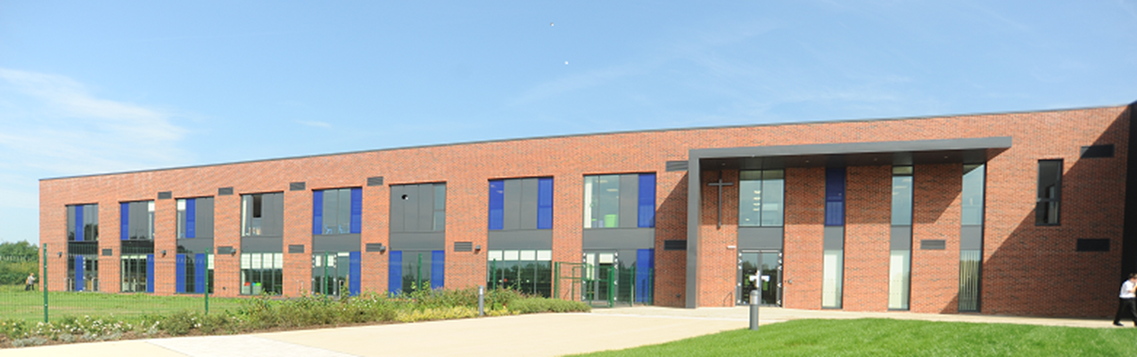

Ryecroft C.E. Middle School
English Teacher
FIXED TERM CONTRACT TO COVER MATERNITY LEAVE
Required from May 2021 to Easter 2022
0.8FTE or full-time will be considered
(Please state your preference for 0.8fte or full-time in your application)

Our popular, happy and thriving school is seeking to appoint a KS2 English specialist who demonstrates excellent classroom practice with the ability to motivate and inspire. The post would suit a newly qualified teacher with real potential or an experienced teacher who is already an outstanding practitioner.
Part of the Uttoxeter Learning Trust, Ryecroft Middle School is an excellent 9-13 years middle school set in beautiful surroundings, at the heart of the community.

Teachers with a background in primary or middle school education are welcome to apply.
We are looking for someone who:
- Is a dynamic, talented and highly effective teacher
- Has high expectations of learning
- Has the ability to inspire others
- Has an excellent knowledge of the curriculum
- Has good organization and interpersonal skills
- Has a friendly and caring nature
- Is prepared to play an active part in all aspects of school life including extra-curricular activities
We can offer the successful candidate:
- Enthusiastic and well behaved pupils
- High expectations of pupil achievement and behaviour
- A strong commitment to raising levels of attainment through a creative approach to the curriculum
- A friendly working environment with supportive and dedicated colleagues
- Opportunities for training and professional development
- Supportive parents and Governors
- A ‘Good’ school - Ofsted Inspection November 2017.

If you would like to discuss this position further please contact our Headteacher, Miss Rachael Baramuszczak 01889 590394
Further information about our school can be found on our website www.ryecroft.staffs.sch.uk
Closing date: Monday 29th March 2021 – 12.00 noon
Interviews: Week commencing Monday 19th April 2021 – actual date TBC

An Application Form, Job Description and Person Specification can be found below.
Applications should be submitted with a covering letter by email to: office@ryecroft.staffs.sch.uk
CV’s alone will not be accepted
Candidates who are shortlisted will be informed by telephone or email.

The Trust is an equal opportunities employer committed to safeguarding and promoting the welfare of children and young people/vulnerable adults and expect all staff and volunteers to share this commitment. This position is subject to a criminal records check from the Disclosure and Barring Service (formerly CRB) which will require you to disclose details of all unspent and unfiltered spent reprimands, formal warnings, cautions and convictions in your application form

