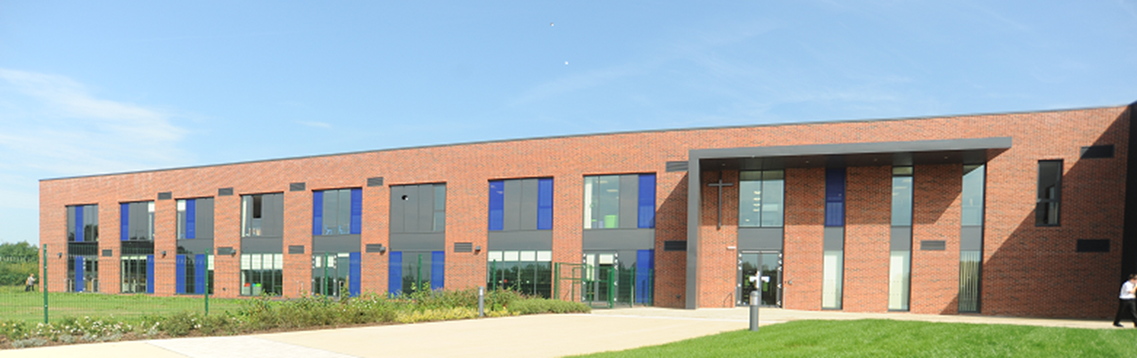

Ryecroft C.E. Middle School
Teaching Assistant
(Occasional cover)
To support an Individual child in Year 5
Required for September 2021 start – fixed term contract
32.5 hours per week – Term Time
(Grade 4 – Point 5)
We require an experienced and highly skilled organised professional to join our classroom support team. Key responsibilities include working as part of our pastoral and inclusion team, offering strong behavioural management skills and to support an individual pupil to overcome barriers to learning. The successful candidate will therefore need to have excellent literacy and numeracy skills. The ability to offer interventions especially phonics is desirable.

PLEASE NOTE: This position is available through funding to provide individual support for a particular pupil in Year 5. Therefore, the job role will only continue for as long as the pupil attends Ryecroft and funding is in place – we expect this to be until summer 2025 but cannot be guaranteed.
A willingness to provide emergency first aid cover would be beneficial for which training would be provided.
Part of the Uttoxeter learning Trust, Ryecroft Middle School is an excellent 9-13 years middle school set in the beautiful surroundings and at the heart of the community. Part of the Uttoxeter Learning Trust, Ryecroft Middle School offers exceptional opportunities for staff development and experience across other key stages and post 16 education.

The school was deemed overall good at the last Ofsted report in November 2017. Our successful middle school has a strong commitment to raising levels of attainment through a creative approach to the curriculum. We can offer you a friendly working environment with a supportive and dedicated team of colleagues and enthusiastic and well behaved pupils.

Closing date: Monday 7th June 2021 - midday
Interviews: Monday 14th June 2021

Candidates who are shortlisted will be informed by telephone or email, if possible.

If you would like to discuss this position further or arrange to visit the school, please contact our Deputy Headteacher, Mr Steve Bardon 01889 590394
Further information about our school can be found on our website www.ryecroft.staffs.sch.uk
An Application Form, Job Description and Person Specification can be found below.
Applications should be submitted with a covering letter by email to: office@ryecroft.staffs.sch.uk

CV’s alone will not be accepted
The Trust is an equal opportunities employer committed to safeguarding and promoting the welfare of children and young people/vulnerable adults and expect all staff and volunteers to share this commitment. This position is subject to a criminal records check from the Disclosure and Barring Service (formerly CRB) which will require you to disclose details of all unspent and unfiltered spent reprimands, formal warnings, cautions and convictions in your application form

