English Texts Overview
Year | Autumn Term |  | Spring Term | Summer Term
5 | Daredevils  Spotlight Texts: 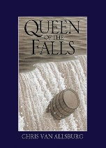  Queen of the Falls by Chris Van Allsburg  An illustrated picture book - biographical  Excerpts:  Survivors: Extraordinary Tales From The Wild And Beyond by David Long and Kerry Hyndman  Related texts selected from Ashley Booth Reading Scheme (Y5) such as:  Shackleton’s Journey by William Grill  How Parachutes Work  The Unsinkable Molly Brown | Daredevils  Spotlight Texts:  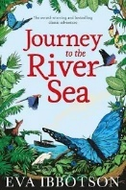  Journey to the River Sea by Eva Ibbotson  Adventure fiction/historical fiction  Excerpts:  The Report Book by Sue Palmer  Related texts selected from Ashley Booth Reading Scheme (Y5) such as:  Kensuke’s Kingdom by Michael Morpurgo  The Explorer by Katherine Rundell  The Children’s Poetry Archive | Novel Study  Spotlight Texts:  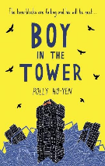  The Boy in the Tower by Polly Ho-Yen  Science Fiction/Adventure/ Dystopian  Excerpts:  Selected examples of age-appropriate advice/warning leaflets  Window by Jeannie Baker  Poetry:  Selected examples from Overheard in a Tower Block by Joseph Coelho | Future Worlds  Spotlight Texts:  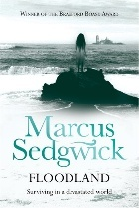  Floodland by Marcus Sedgewick  Science Fiction  Excerpts:  Flow (U)  Our Planet:The One Place We Call Home by Matt Whyman and Richard Jones  Little People, Big Dreams: Greta Thunberg  Greta Thunberg speeches  The Children’s Poetry Archive
6 | In Flashback  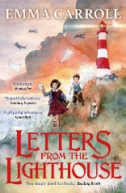  Spotlight Texts:  Letters From The Lighthouse by Emma Carroll  Historical Fiction  Excerpts:  When the Sky Falls by Phillip Earle  Historical Fiction  Star of Fear, Star of Hope by Jo Hoestlandt  An illustrated picture book – Historical Fiction  The Lion, The Witch and The Wardrobe by C.S.Lewis  Classic Fiction | Novel Study  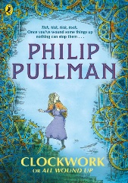  Spotlight Texts:  Clockwork or All Wound Up by Phillip Pullman  Excerpts:  The Children’s Poetry Archive  Can We Save The Tiger?    Spotlight Texts:  Can We Save The Tiger? By Martin Jenkin  Information | Camp Green Lake  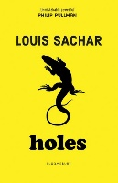  Spotlight Texts:  Holes by Louis Sachar  Young Adult/Contemporary Fiction  Stanley Yelnats’ Survival Guide by Louis Sachar  Humour/Non-Fiction  Excerpts:  Private Peaceful by Michael Morpurgo  The Instruction Book by Sue Palmer/ The Explanation Book by Sue Palmer  Teachers will select a range of texts to include fiction, non-fiction, playscript and poetry (from a range of authors and perspectives) to broaden exposure to texts in preparation for SATs. | Books On Film and Free Writing  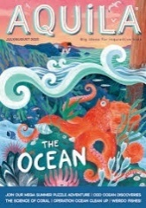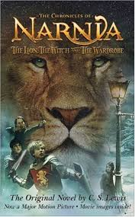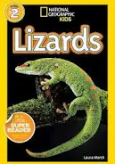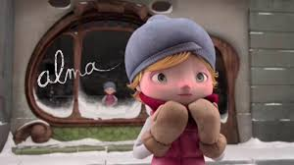  Teachers will provide a range of opportunities for children to produce informed, independent writing. These are selected from a variety of sources including:  Literacy Shed/Pixar Shorts  Surreal Art/Photography  Evacuee Letters/Soldier Letters  The Lion, The Witch and The Wardrobe by C.S. Lewis  National Geographic Kids/Aquilla  Reviews

Year | Autumn Term | Spring Term | Summer Term
7 | Novel Study  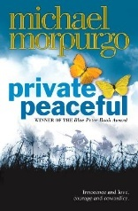  Spotlight Texts:  Private Peaceful by Michael Morpurgo  Excerpts:  Selected war poetry  Soldier letters and diaries  Non-fiction texts suitable for pupil research  Propaganda posters  Radio Play – 16 Minutes | The Power Of Nature  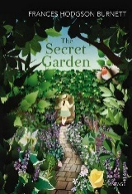  Spotlight Texts:  The Secret Garden by Frances Hodgson Burnett  Excerpts:  Selected romantic/pastoral poetry  Selected travel writing pieces  A Midsummer Night’s Dream by William Shakespeare  Shakespeare In Short Video Clips | Home And Other Stories  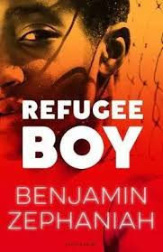  Spotlight Texts:  Refugee Boy by Benjamin Zephaniah  Excerpts:  Selected poetry on identity and belonging including poems from a range of cultures  The Arrival by Shaun Tan  The Song Walker by Zillah Bethall
8 | Mysteries Unveilled  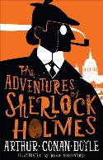  Spotlight Texts:  A Scandal in Bohemia by Sir Arthur Conan Doyle  Selected poetry by Wordsworth and Blake  Excerpts:  Sherlock: The Hound of the Baskervilles BBC (12)  Enola Holmes: The Case of the Missing Marquess by Nancy Springer | Literary Heritage Unit: Shakespeare Study    Spotlight Texts:  The Tempest by William Shakespeare  Excerpts:  The Tempest (12)  Selected short stories linked thematically to the play | Whispers In The Dark  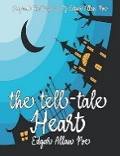  Spotlight Texts:  The Tell-Tale Heart by Edgar Allen Poe  The Monkey’s Paw by W.W. Jacobs  Excerpts:  The Laboratory by Robert Browning | Moving On  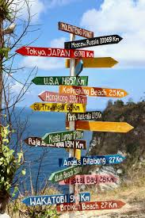  Teachers will provide a range of opportunities for children to produce informed, independent writing.  These are used to support transition to high school.

