Pupil-Friendly Apps and Websites

We use a range of pupil-friendly apps and websites to support our learning in school. These are loaded onto pupil iPads. However, you will find all the links you need to support learning at home below:

KS2

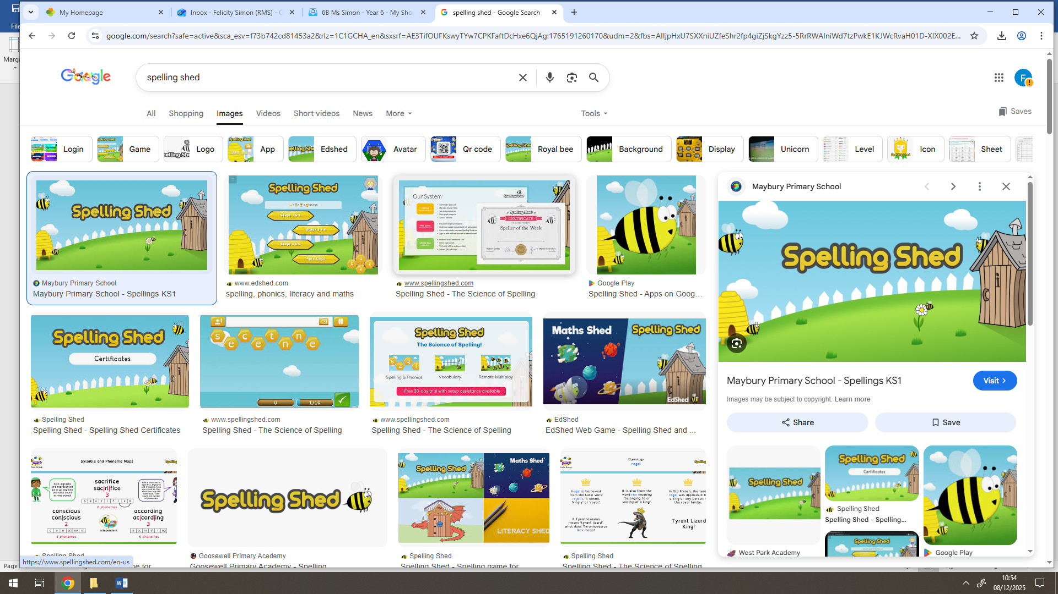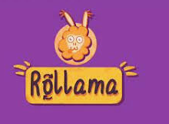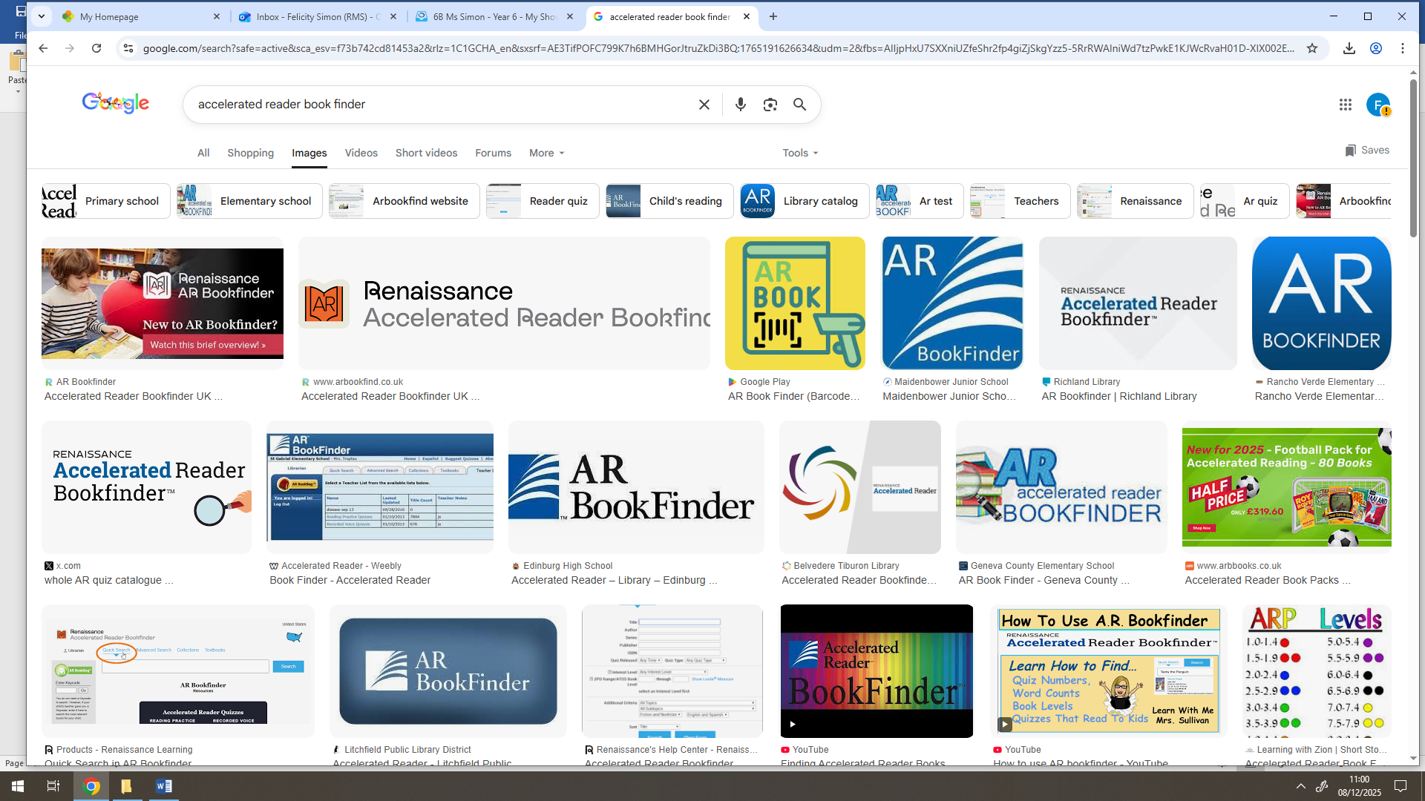

Work on your spellings at home and Work on grammar and punctuation Check if a book is in
get ready for our weekly spelling test. at home to reinforce classroom learning. your ZPD range.

KS3

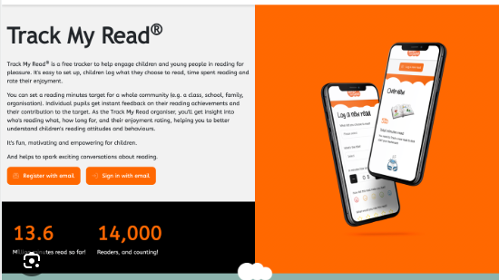

Record your reading electronically. Check if a book is in your ZPD range.

Please reach out to your child’s English teacher if you have any difficulties in accessing these apps/websites. If your child is in KS2, their login details will be found in their reading diary.

