Ryecroft C.E. Middle School
Year 5 English Long- Term Plan
Calendar | Topic |  | Assessment | GPS Links | Vocabulary
Y5 Autumn Term | Spotlight Text: Queen of the Falls by Chris Van Allsburg  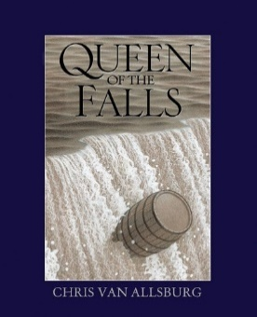  Supplementary Texts:  Survivors: Extraordinary Tales From The Wild And Beyond by David Long and Kerry Hyndman  Related texts selected from Ashley Booth Reading Scheme (Y5) such as:  Shackleton’s Journey by William Grill  How Parachutes Work  The Unsinkable Molly Brown  Kensuke’s Kingdom by Michael Morpurgo  The Explorer by Katherine Rundell | Spotlight Text:  Journey to the River Sea by Eva Ibbotson  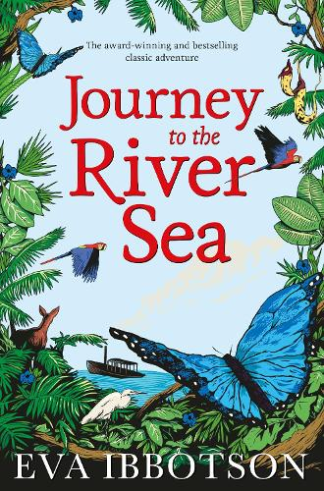  Supplementary Texts:  The Report Book by Sue Palmer  Related texts selected from The Children’s Poetry Archive | Reading- Accelerated Reader Star in September and December. Testbase Autumn Term Y5 Reading paper December.  Writing - Pupils are heavily scaffolded for writing until December – cold write at the beginning and end of each half term to measure skills against the grid and inform teaching.  Spelling: Y3/4 curriculum spelling assessment  All lesson follow our agreed structure:  Recall  Receive  Respond.  Handwriting: Pupils have regular opportunities for handwriting to support them with cursive writing. These are linked to statutory spelling words where possible.  Dictation: Pupils have regular opportunities for short dictation pieces which link to KS2 statutory spelling words.  Weekly homework tasks – each week, pupils must read for up to 90 minutes outside of school and log their reads in their reading diaries, which parents/carers are asked to sign. Teachers must complete a weekly read in ‘check in’ to monitor progress against this goal and utilise our Reading Riches scheme/intervene as appropriate.  Pupils also complete Spelling Shed games over the week which links to our low-stakes spelling test.  There is also an additional homework task: Reading comprehension, vocabulary task, pre-reading task, grammar task or Rollama game.  . | Spelling Progression:  Teachers will use their question level analysis findings from the Y3/4 spelling assessment to identify whole class spelling gaps or misconceptions. During Autumn 1, teachers will focus on addressing these gaps in their weekly spelling sessions and corresponding homework.  In Autumn 2, pupils will move on to:  tious and ious  cious  cial  tial  cial and tial  ant  ance ancy  ent ence  able and ible  Grammar Progression:  The majority of our grammar is woven into our writing units to help pupils contextualise their learning. There may be occasion for some ‘stand alone’ lessons according to content and pupil need  Word class: nouns, adjectives, verbs adverbs, noun phrases and expanded noun phrases, proper nouns  Sentence boundary punctuation: capital letters, full stops, exclamation marks and question marks  First and third person  Sentence functions: statement, command, question and exclamation  Simple sentence, main clause and independent clause  Compound sentence and coordinating conjucnctions  Complex sentence, subordniate clause and subordinating conjunctions  Fronted adverbials  Contractions  Paragraphs  Simple past tense, simple present tense, simple future tense  Direct speech, dialogue and inverted commas | Tier 2 Vocabulary Sample  Allowance Bustle Conclusion Crooning Emerged Formidable Imagination Lingered Mishap Narrow Passage Plunge Sullen Trudged Trustworthy | Tier 3 Vocabulary  Sample  Biographical Matinee Monologue Quayside Simile Quayside
Structured Oracy
We use ‘Talk For Writing’ approaches regularly within lessons and ‘Reader’s Theatre’ opportunities. We have also embedded echo, choral and repeated reading within our classrooms. However, weand also provide structured oracy opportunities (see below for examples)

Role Play:
Act out a conversation as Mrs Minton/Maia and other characters from Journey to the River Sea. This will support the writing of dialogue.
Act out a conversation between Annie and her interviewer after she achieved her daredevil feat.

Hot-Seating:
Role-play as Annie and her best friend to consider views on whether Annie should take the plunge. This will support informal letter writing.

Dramatic Speech:
Pupils write a dramatic speech/monologue in role as a villain. There are opportunities to perform examples in small groups and for pupils to perform their final piece.

Performance Poetry:
Pupils will be given opportunities to perform poetry for an audience of classmates, assembly or parents.

Reading For Pleasure
Library visits 1 per fortnight (15 – 20 minutes) in tutor time.
Book tasting session 1 per half term.
Sponsored Read
Fiction Writing Opportunities  Setting description  Monologue/dramatic speech  Dialogue between characters/conversation |  |  |  | Non-Fiction Writing Opportunities  Informal letter  Interview  Non chronological report

