Ryecroft C.E. Middle School
KS3: English Long- Term Plan
Calendar | Topic | Assessment | Sequencing and Coherence  Knowledge - Themes - | Vocabulary
Y7 Autumn Term | Dulce Et Decorum Est  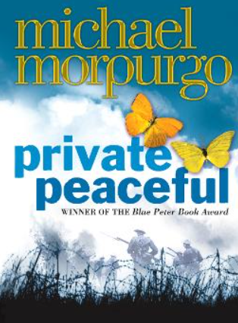  Spotlight Text: Private Peaceful by Michael Morpurgo  Supplementary Texts:  Selected war poems, soldier letters and diary entries (1914-1918)  Selected non-fiction sources for contextual research  Pupils complete a novel study of Private Peaceful and examine a variety of non-fiction sources, including soldier diaries and letters, to develop a deeper understanding of historical and social context. They also analyse war poetry, engaging with both contemporary works and poems written during the period of World War One. In addition, pupils explore propaganda posters to further enhance their understanding of the era. | Reading- Accelerated Reader Star in September and December.  Writing - Pupils are heavily scaffolded for writing until December – cold write at the beginning and end of each half term to measure skills against the grid and inform teaching.  All lesson follow our agreed structure:  Recall  Receive  Respond.  Weekly homework tasks – each week, pupils must read for up to 90 minutes outside of school and log their reads using TrackMyRead.com. Teachers must complete a weekly read in ‘check in’ to monitor progress against this goal and utilise our Reading Riches scheme/intervene as appropriate.  Pupils also complete an additional homework task designed to either consolidate key skills or support pre-learning. These tasks are carefully selected and may focus on vocabulary and spelling, reading comprehension, writing, or grammar and punctuation. | Literary themes:  War and morality  Courage, hope and resistance  Identify and belonging  Memory and time  Sacrifice  Injustice and inequality  Disciplinary Knowledge:  Pupils recognise and use a range of writing techniques, including alliteration, onomatopoeia, personification, simile and metaphor, and sensory imagery.  They develop an understanding of poetic techniques, form, structure, and their impact on the reader.  Pupils explore denotation and connotation in images and visual texts, such as propaganda posters. They investigate how propaganda functions to persuade, particularly in wartime contexts,  They distinguish between narrative voice and character voice, considering the role and limitations of the omniscient narrator.  Pupils analyse text structure, including shifts from chronological to non-linear narratives and the effects of flashback and flashforward.  Pupils examine the impact of emotive language and key writing techniques, including foreshadowing and irony, on meaning and audience response.  Potential Visitor: William Coltman  Potential Trip: National Memorial Arboretum | Tier 2 Vocabulary Sample  Allegiance  Ambiguity  Betrayal  Bravery  Censorship  Conscience  Conviction  Courage  Dilemma  Disability  Empathy  Ethics  Justice  Loyalty  Manipulation  Morality  Narrative  Patriotism  Persuasion  Propoaganda  Psychological  Recollection  Sacrifice  Solidarity  Trauma | Tier 3 Vocabulary  Sample  Artilery  Battalion  Conscientous objector  Conscript  Court Martial  Frontline  Infantry  No Man’s Land  Proaganda  Reconnaisance  Regiment Shellshock  Shrapnel  Sniper  Trench
Structured Oracy
Voice 21 Focus: reasoning together, justifying opinions, speaking fluently and expressively

Debate - Motion: “Private Peaceful is an anti-war novel.”
Format: Formal class debate (parliamentary style or balloon debate), with students in teams researching and presenting arguments, followed by rebuttal rounds.

Hot-Seating:
Role-play as Tommo, Charlie, or William Coltman and respond to class questions in character.
Focus: Empathy, inference, and oral improvisation.

Propaganda Speech:
Deliver a short persuasive speech.
Focus: Use of rhetorical devices (AFOREST), performance skills, and emotional impact.

Audiobook/Radio Drama Piece:
Serialise part of Private Peaceful. Pupils are asked to write, produce and direct their piece.

Reading For Pleasure
Library visits 1 per fortnight (15 – 20 minutes) in tutor time.
Book tasting session 1 per half term.
Sponsored Read
Fiction Writing Opportunities  Setting description/ story openings incorporating atmospheric setting description Diary entries (in role).  Free writing task.  Radio drama piece. |  |  | Non-Fiction Writing Opportunities  Baseline – formal letter.  Persuasive speech.  Double page spread/report.  .

